**Employee Feedback system:**

**Author**: Anoop Antony P

**Technologies Used**:

This project has been developed in React.js, Node.js and Mysql

**Front End Technologies** **used**: React.js, React-Bootstrap

**Server-Side Technologies used:** Node.js.

**Framework:** Express.js

**DataBase**: MySql

**How to install/Run the application**:

1. Copy the folders “**employee-ui** and **employee-api”** to your drive and import “**paypaydb.sql**” to “**paypaydb**” (db name)
2. Navigate to inside the folder **employee-ui** and **employee-api**
3. Open command prompt with the respective locations and type “**npm install**” and then after installation type “**npm start**”

**Modules**

**Login Screen**:

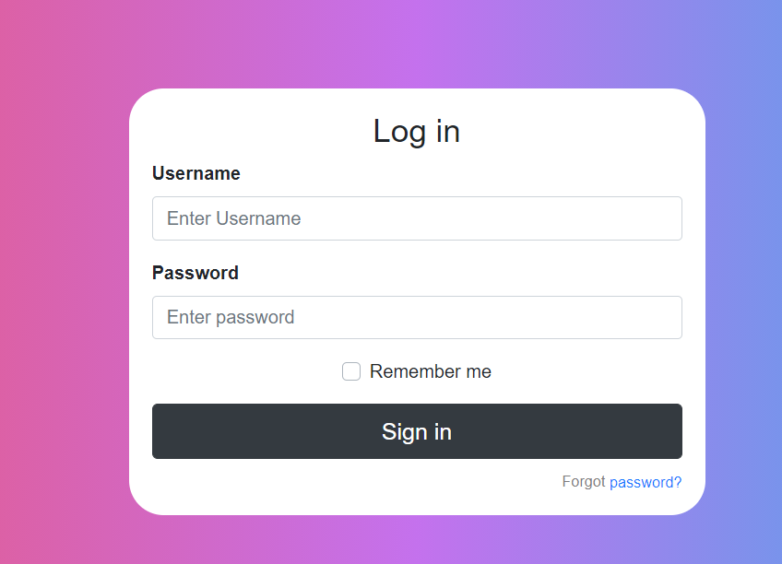

1. Login with **username**: anoop and **password**: anoop for admin access
2. Login with **username**: neenu123 and **password**: 123 for employee access
3. **Remember me** and **Forgot password** are just dummy links

**Admin Modules:**

Screen 1: landing page

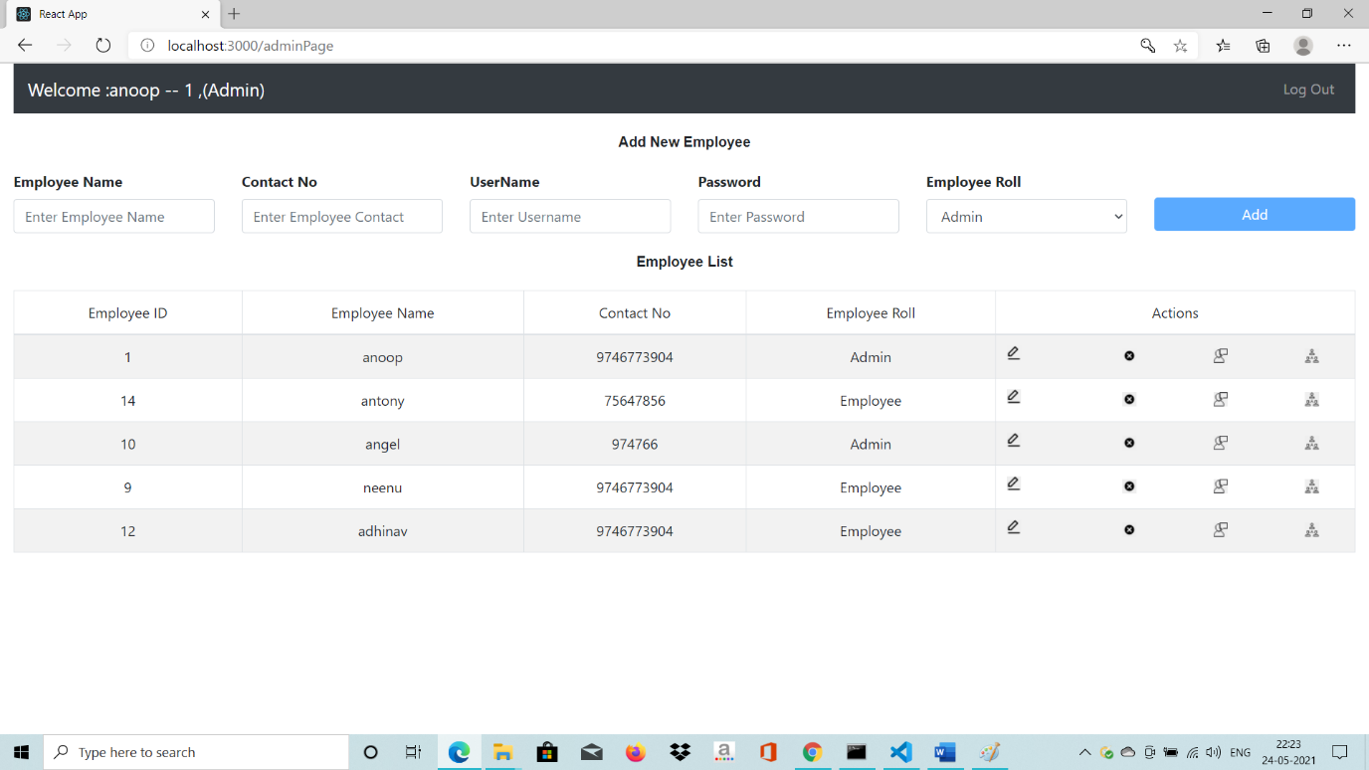

* Enter employee name, contact, username, password and emp roll to enable the add button
* Click on add to add employee to the system. With the provided username and password the user can access the system
* Multiple Admin roll can be enrolled.
* Can modify the roll of a user.
* The details can be modified, deleted (using first two icons)

Edit screen as below:

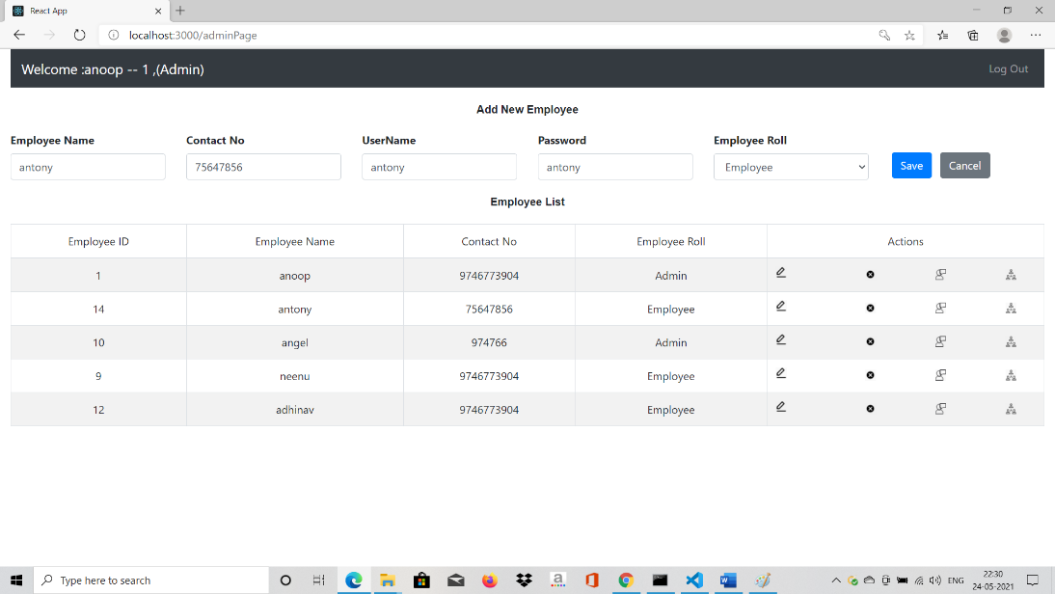

* To enable other button the user need to either save or cancel
* **Note: The logged in user cannot edit/delete himself**
* The admin can provide feedback using the third icon in the actions column. And the below screen is visible on the click of the icon
* Admin can click on self for listing out the feedback provided to him by some other persons, currently admin can also enter some notes to himself (this feature can be disabled)

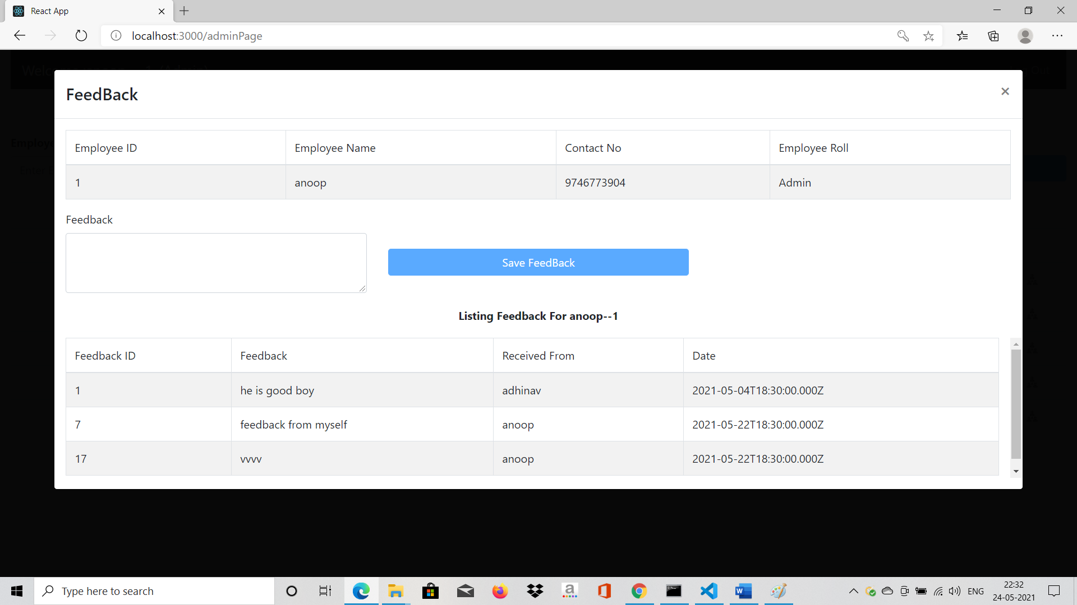

Tagging Employee screen:

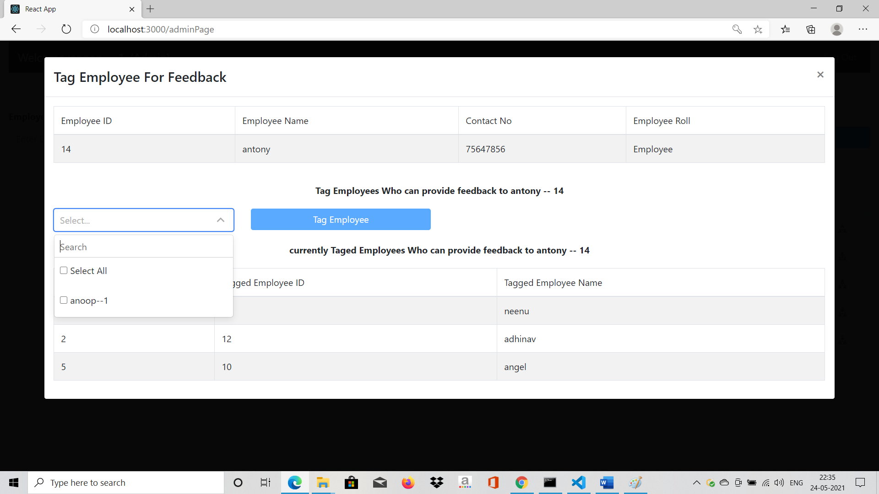

* Here admin can tag each employee to many employee using an multi select dropdown with search
* The tagged employees and the selected employee details will not be listed in the select box.

**Employee Screen:**

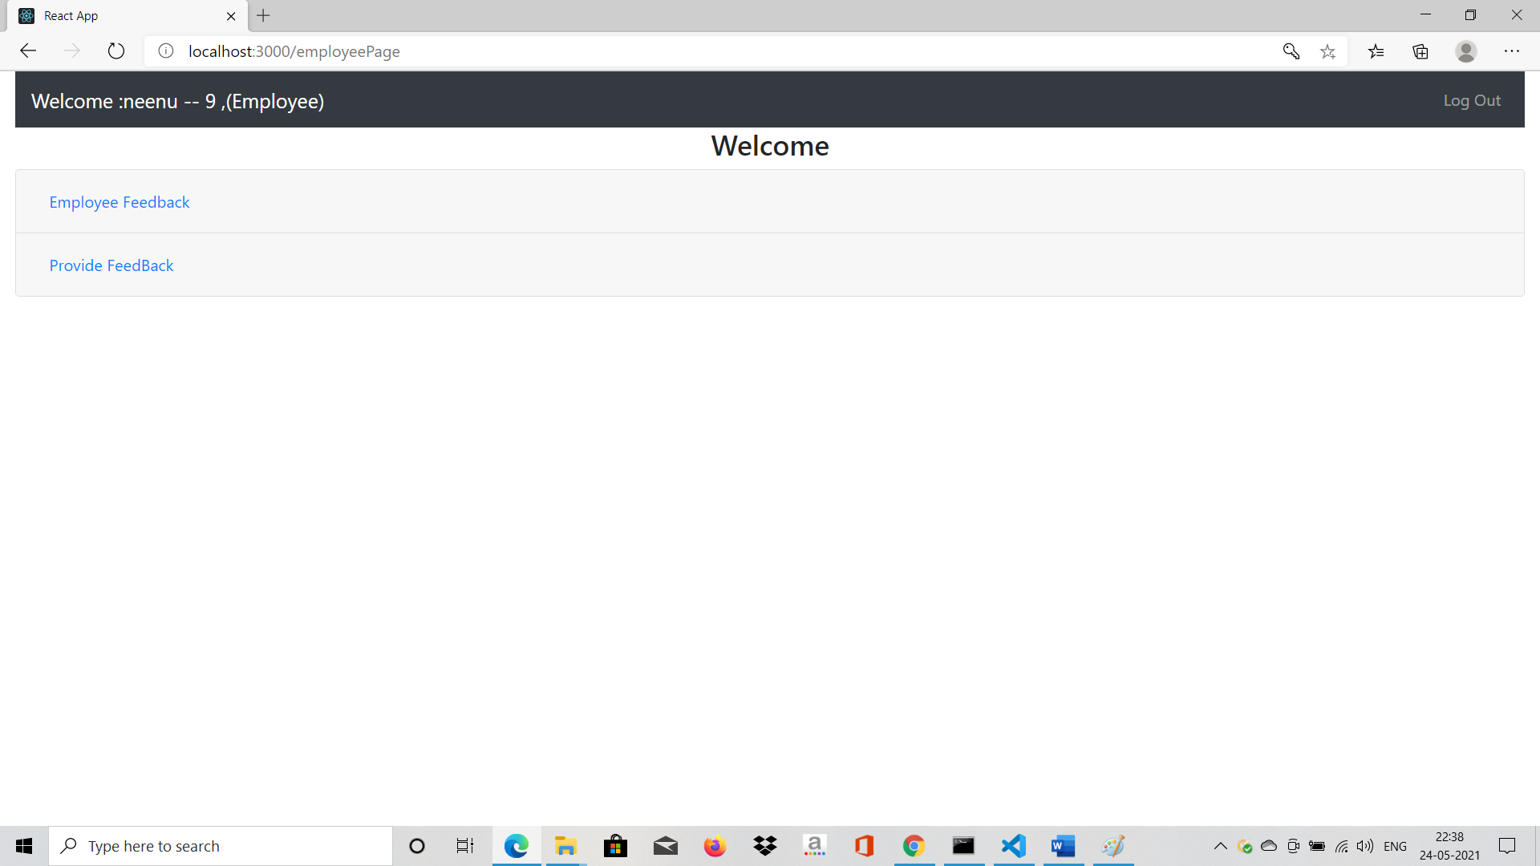

* Click on employee feedback accordion to see the feedback provided to him by other employees who are tagged by admin
* 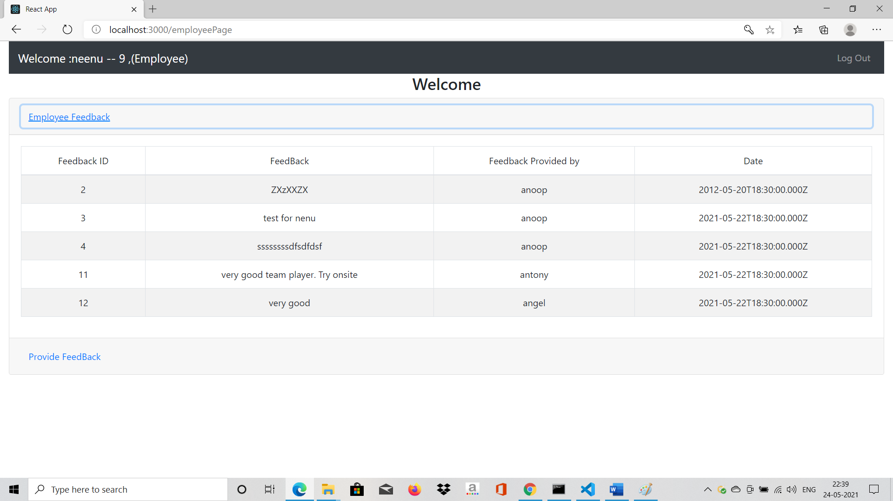
* Click on provide feedback according to list down the associate who are tagged under him and thus he can provide feedback to those employee as below screen

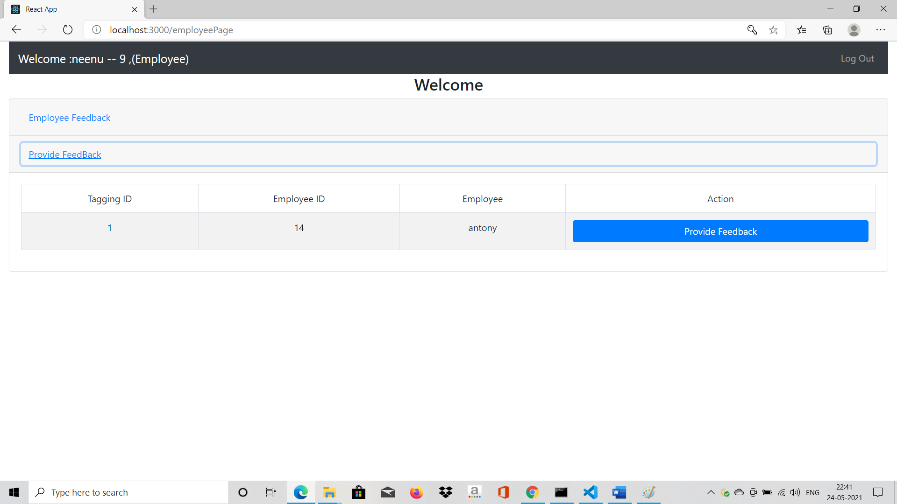

* Provide feedback by clicking on the provide feedback button

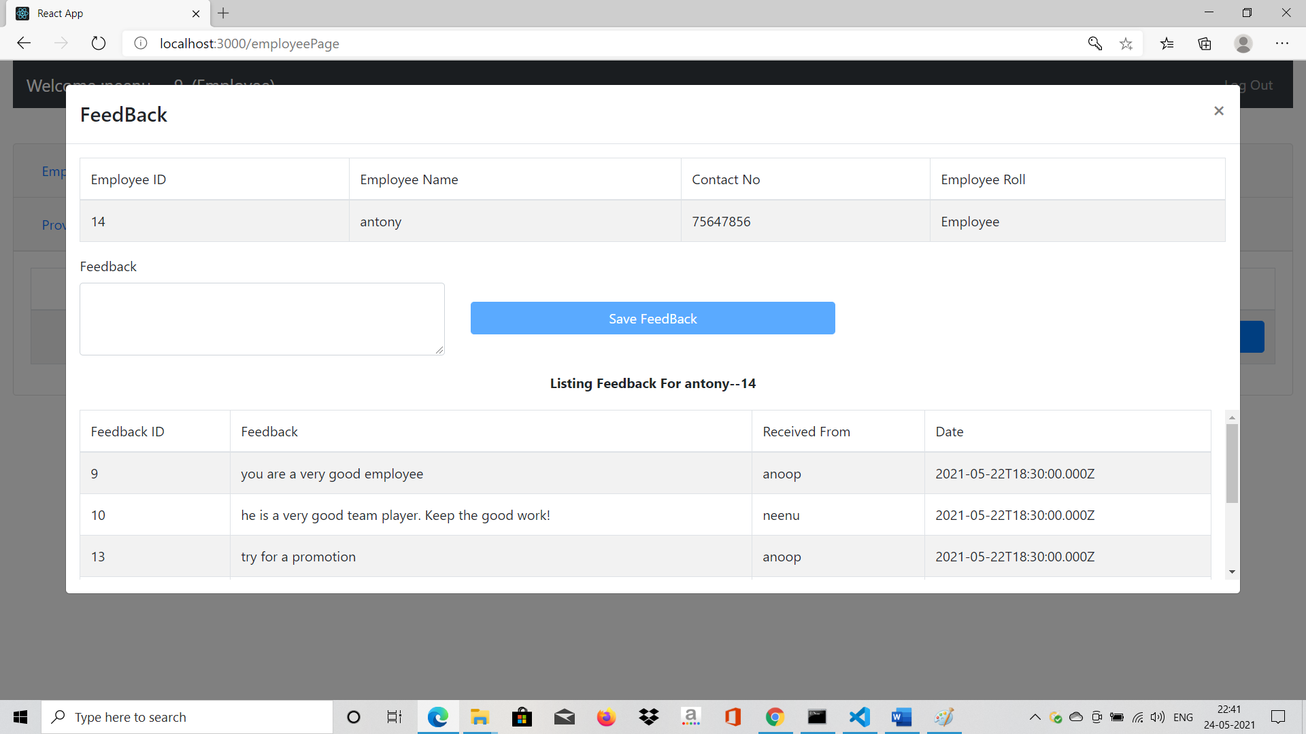

While providing feedback he could review the feedback provided by any other employees.